|  |  |  |  |  |  |  |  |  |  |
| --- | --- | --- | --- | --- | --- | --- | --- | --- | --- |
| **SCHOOL OF COMPUTER SCIENCE AND ARTIFICIAL INTELLIGENCE** | | | | | **DEPARTMENT OF COMPUTER SCIENCE ENGINEERING** | | | | |
| **ProgramName:**B. Tech | | | | **Assignment Type: Lab** | | | **AcademicYear:**2025-2026 | | |
| **CourseCoordinatorName** | | | | Venkataramana Veeramsetty | | | | | |
| **Instructor(s)Name** | | | | 1. Dr. Mohammed Ali Shaik  2. Dr. T Sampath Kumar  3. Mr. S Naresh Kumar  4. Dr. V. Rajesh  5. Dr. Brij Kishore  6. Dr Pramoda Patro  7. Dr. Venkataramana  8. Dr. Ravi Chander  9. Dr. Jagjeeth Singh | | | | | |
| **CourseCode** | | | 24CS002PC215 | **CourseTitle** | | AI Assisted Coding | | | |
| **Year/Sem** | | | II/I | **Regulation** | | R24 | | | |
| **Date and Day**  **of Assignment** | | | Week2-Tuesday | **Time(s)** | |  | | | |
| **Duration** | | | 2 Hours | **Applicableto**  **Batches** | | 24CSBTB01 To 24CSBTB39 | | | |
| **AssignmentNumber:3.2**(Present assignment number)/**24**(Total number of assignments) | | | | | | | | | |
|  | | | | | | | | | |
|  | **Q.No.** | **Question** | | | | | | ***ExpectedTime***  ***to complete*** |  |
|  | 1 | Lab 3: Prompt Engineering – Improving Prompts and Context Management  **Lab Objectives:**   * To understand how prompt structure and wording influence AI-generated code. * To explore how context (like comments and function names) helps AI generate relevant output. * To evaluate the quality and accuracy of code based on prompt clarity. * To develop effective prompting strategies for AI-assisted programming.   **Lab Outcomes (LOs):**  After completing this lab, students will be able to:   * Generate Python code using Google Gemini in Google Colab. * Analyze the effectiveness of code explanations and suggestions by Gemini. * Set up and use Cursor AI for AI-powered coding assistance. * Evaluate and refactor code using Cursor AI features. * Compare AI tool behavior and code quality across different platforms.   **Task Description#1**   * Ask AI to write a function to calculate compound interest, starting with only the function name. Then add a docstring, then input-output example   **Expected Output#1**   * Comparison of AI-generated code styles   **Task Description#2**   * Do math stuff, then refine it to: # Write a function to calculate average, median, and mode of a list of numbers.   **Expected Output#2**   * AI-generated function evolves from unclear to accurate multi-statistical operation.   **Task Description#3**   * Provide multiple examples of input-output to the AI for convert_to_binary(num) function. Observe how AI uses few-shot prompting to generalize.   **Expected Output#3**   * Enhanced AI output with clearer prompts   **Task Description#4**   * Create an user interface for an hotel to generate bill based on customer requirements   **Expected Output#4**   * Consistent functions with shared logic   **Task Description#5**   * Analyzing Prompt Specificity: Improving Temperature Conversion Function with Clear Instructions   **Expected Output#5**   * Code quality difference analysis for various prompts   **Note: Report should be submitted a word document for all tasks in a single document with prompts, comments & code explanation, and output and if required, screenshots**  **Evaluation Criteria:**   | **Criteria** | **Max Marks** | | --- | --- | | Task#1 | 0.5 | | Task#2 | 0.5 | | Task #3 | 0.5 | | Task #4 | 0.5 | | Task #5 | 0.5 | | **Total** | **2.5 Marks** | | | | | | | 03.08.2025 EOD |  |

**Task Description#1**

* Ask AI to write a function to calculate compound interest, starting with only the function name. Then add a docstring, then input-output example

**Expected Output#1**

* Comparison of AI-generated code styles

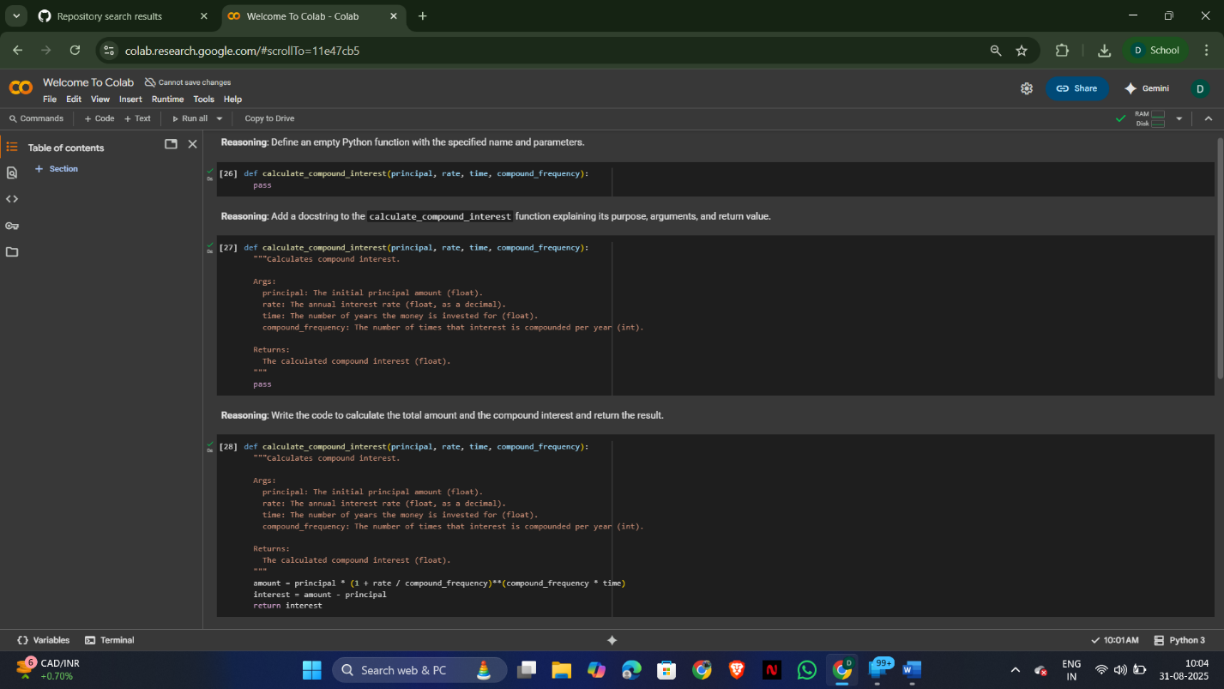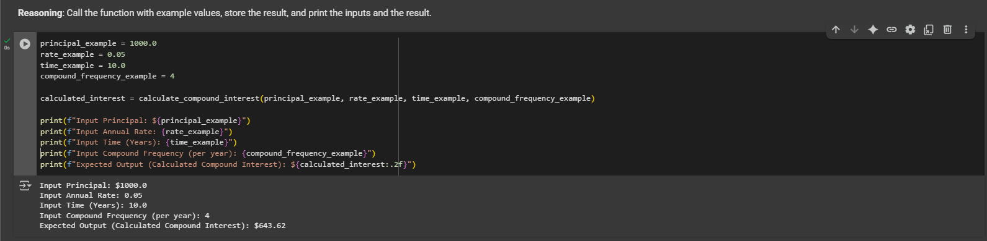

**Task Description#2**

* Do math stuff, then refine it to: # Write a function to calculate average, median, and mode of a list of numbers.

**Expected Output#2**

* AI-generated function evolves from unclear to accurate multi-statistical operation.

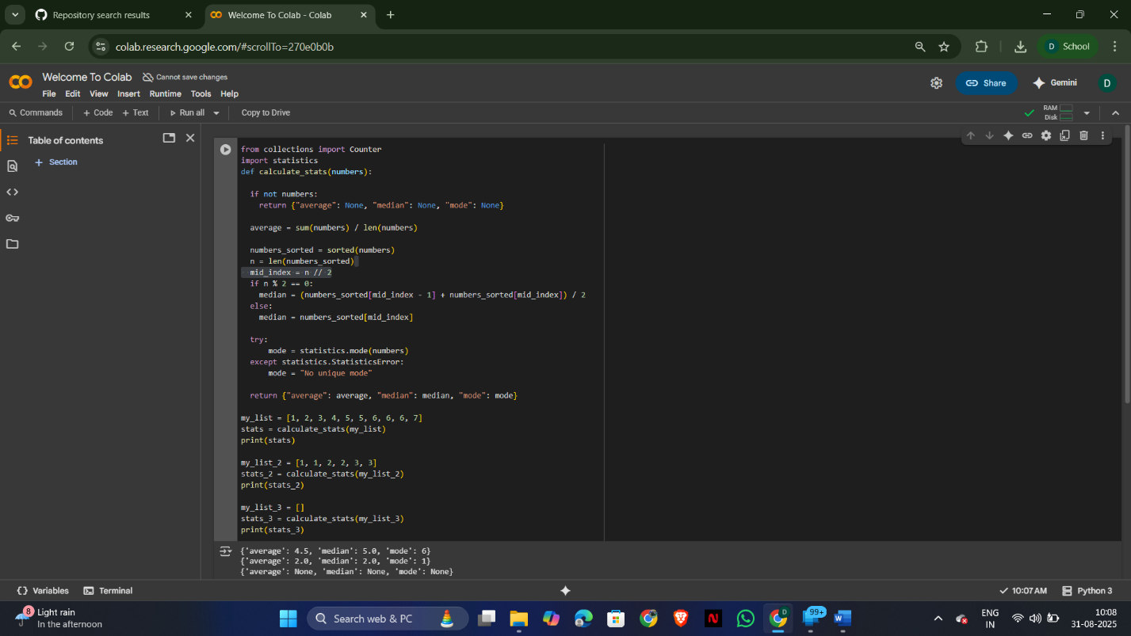

**Task Description#3**

* Provide multiple examples of input-output to the AI for convert_to_binary(num) function. Observe how AI uses few-shot prompting to generalize.

**Expected Output#3**

* Enhanced AI output with clearer prompts

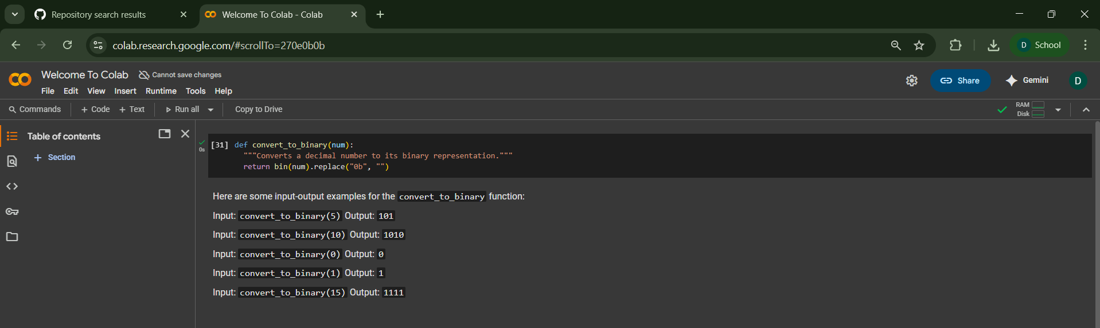

**Task Description#4**

* Create an user interface for an hotel to generate bill based on customer requirements

**Expected Output#4**

Consistent functions with shared logic

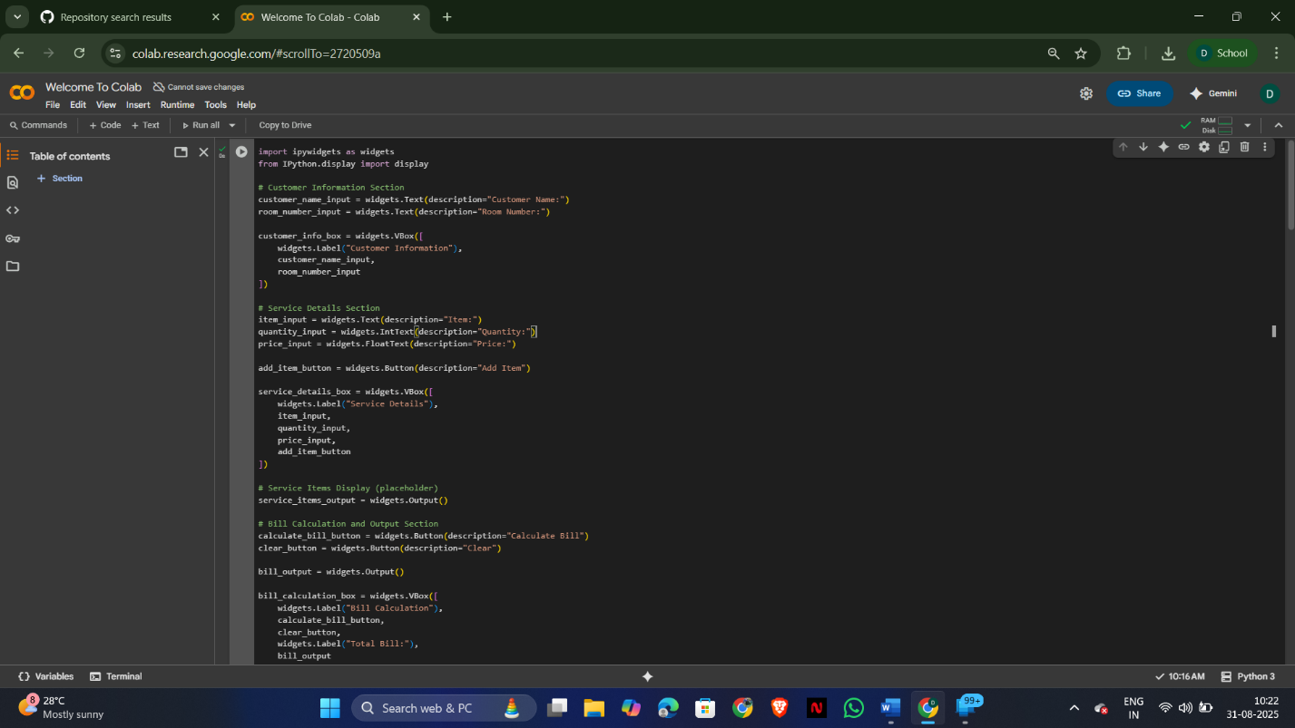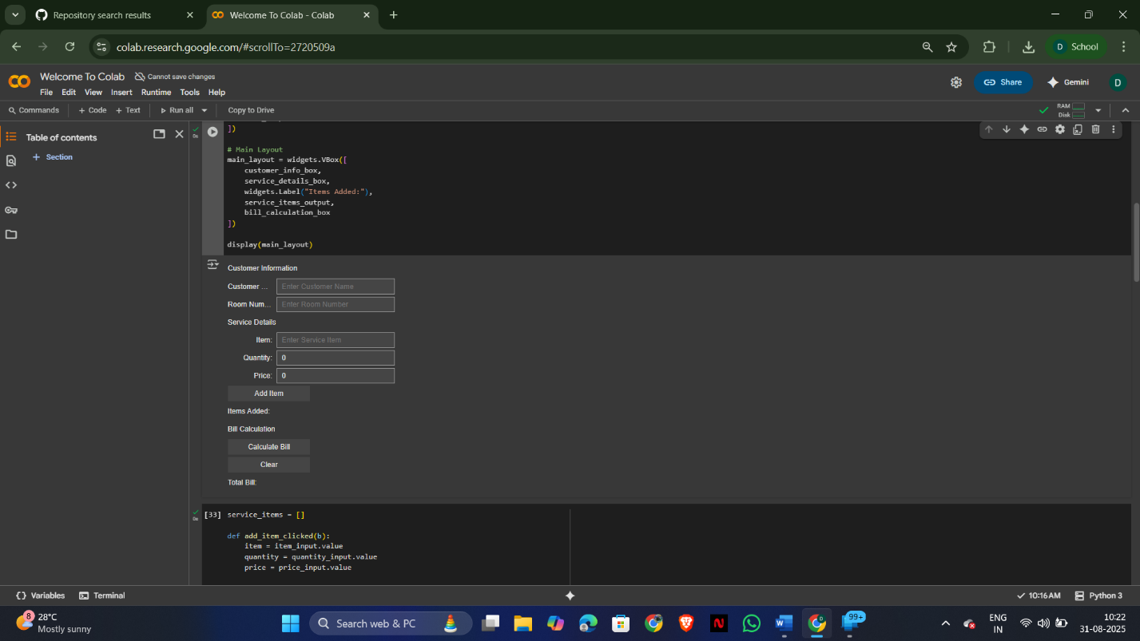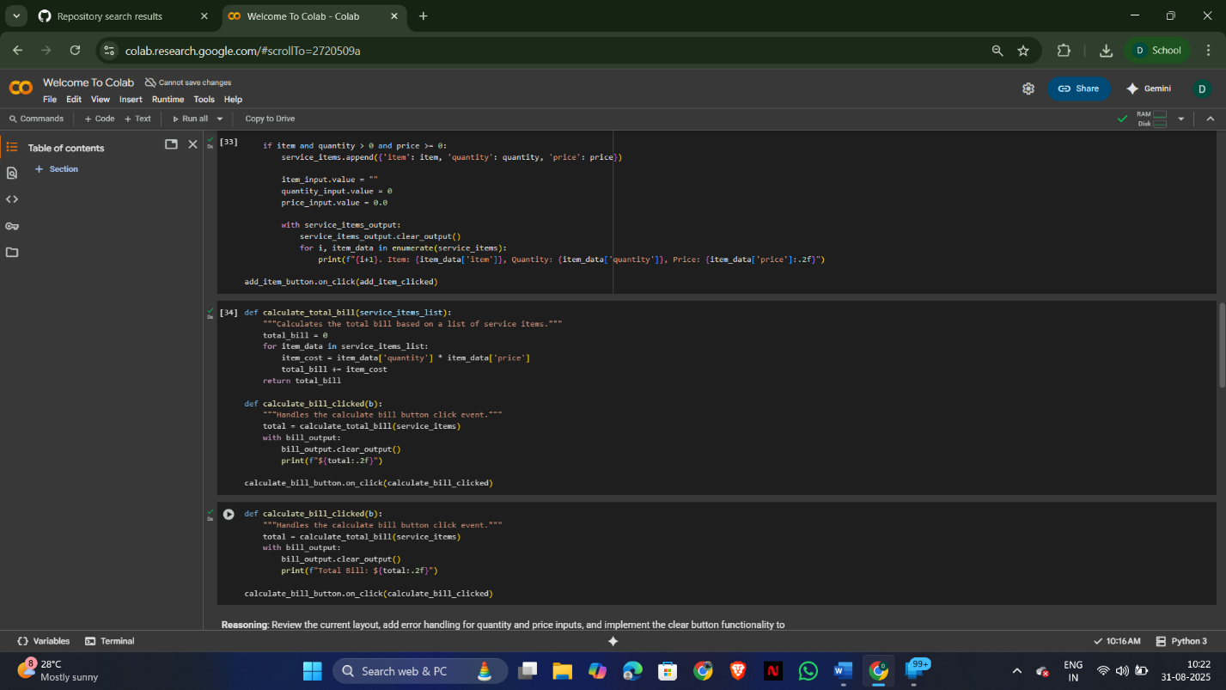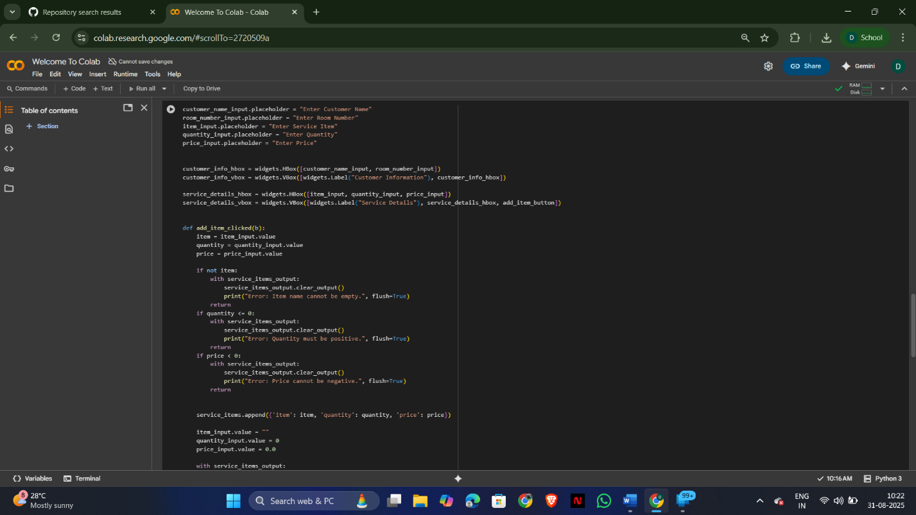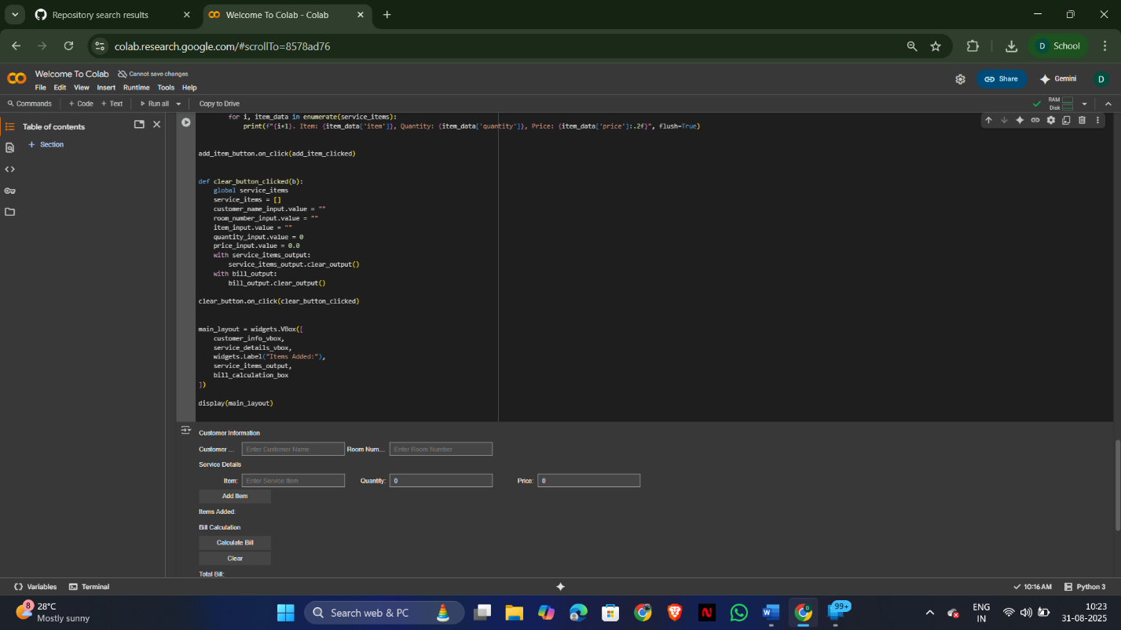

**Task Description#5**

* Analyzing Prompt Specificity: Improving Temperature Conversion Function with Clear Instructions

**Expected Output#5**

* Code quality difference analysis for various prompts

